13.74: a) Solving Eq. (13.12) for , and using 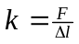
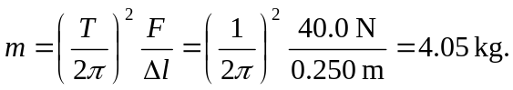

b) the mass has already passed the lowest point of its motion, and is on the way up.
c) Taking upward forces to be positive, 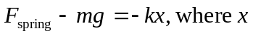is the displacement from equilibrium , so

